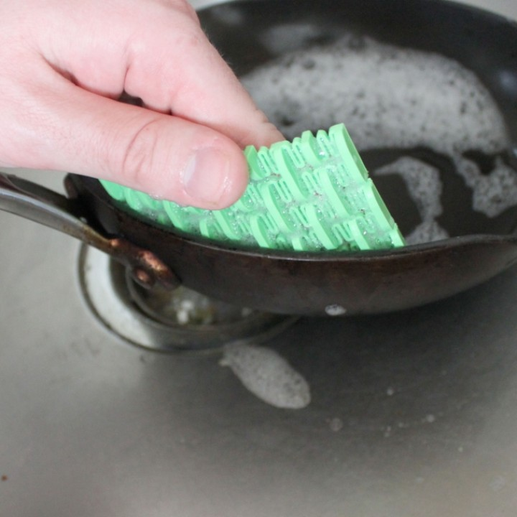The kitchen sponge is commonly known as a very dirty object. It is has been said that there are about 10 million bacteria per square inch of a kitchen sponge, making it about 200,000 times dirtier than a toilet seat.

This 3D-printed kitchen sponge provides a flexible, abrasive surface to scrub away grime. Its impermeable plastic keeps the scrubber from retaining gunk. Works extremely well on burned-on foods and is ideal for non-stick pans.

Designed by Jake Jake @JAS2015

Printed from upcycled PET bottles pultruded from a modified Recreator 3D Mk3 by Green Ellipsis.

https://www.myminifactory.com/object/3d-print-sink-scrubber-8742

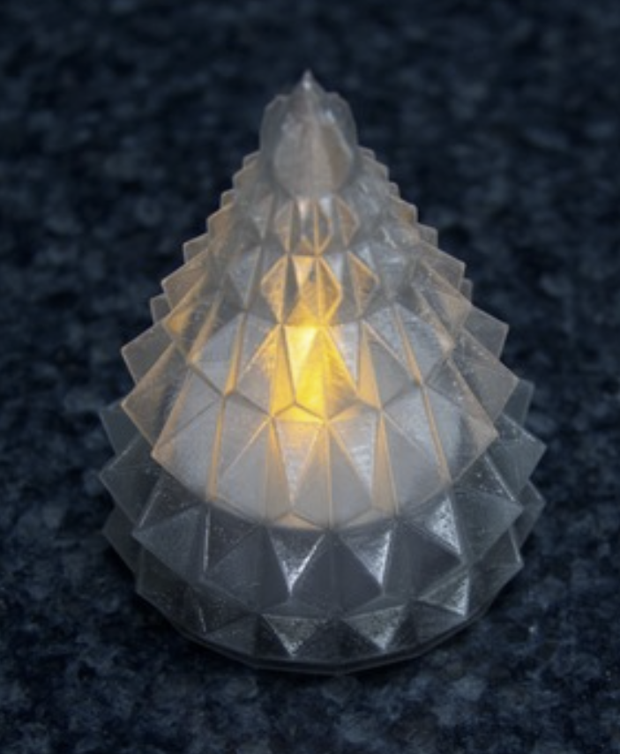A stylized Christmas tree light. The hard edges effectively diffuse light from the LED inside.

Designed by SteedMaker

https://www.thingiverse.com/thing:3144581

Printed from upcycled PET bottles pultruded from a modified Recreator 3D Mk3 by Green Ellipsis. Lit with LEDs reclaimed from Christmas light strings.

The kitchen sponge is commonly known as a very dirty object. It is has been said that there are about 10 million bacteria per square inch of a kitchen sponge, making it about 200,000 times dirtier than a toilet seat.

This 3D-printed kitchen sponge provides a flexible, abrasive surface for scrubbing away grime. Its impermeable plastic keeps the scrubber from retaining gunk. Works extremely well on burned-on foods and is ideal for non-stick pans.

Designed by Jake Jake @JAS2015

Printed from upcycled PET bottles pultruded from a modified Recreator 3D Mk3 by Green Ellipsis.  
  
https://www.myminifactory.com/object/3d-print-sink-scrubber-8742

A stylized Christmas tree light. The hard edges effectively diffuse light from the LED inside.

Designed by SteedMaker  
https://www.thingiverse.com/thing:3144581

Printed from upcycled PET bottles pultruded from a modified Recreator 3D Mk3 by Green Ellipsis. Lit with LEDs reclaimed from Christmas light strings.